Keith Carson

Remote Sensing I

GEOG-5060, Dr. Cross

**ENVI lab Report**

**Lab 1** A Quick Start to ENVI 5

*\*Opening an Image and Applying a Contrast Stretch*

Start Image

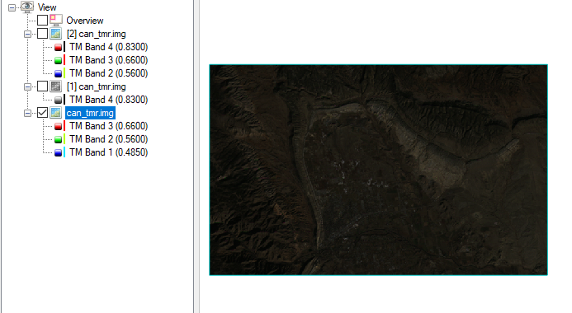

This process opens an image, contrast is not set and the image is hard to see. To make the image clearer, we apply 1% linear stretch from the drop-down tab, directly above the image.

1% linear stretch

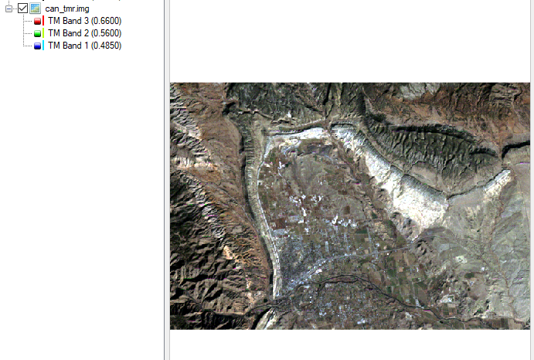

*\*Loading an Image to the ENVI Display*

In this step we start to explore other bands by displaying the image band 4 (near inferred). Since NIR isn’t visible to the human eye, ENVI displays the data on a greyscale.

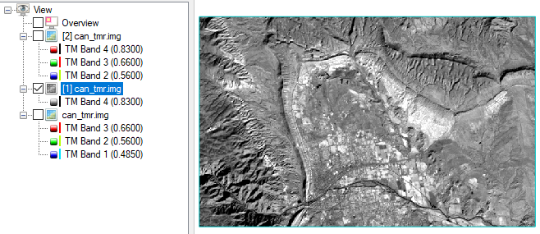

Here, we load an image rendering different bands as red, blue and green to create a 4,3,2 color. This produces a false color composite. To do this, we utilized the “Data manager” in the tool ribbon located immediately below the edit tab.

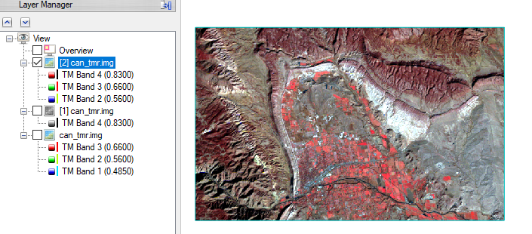

*\*Opening and Linking Multiple Views*

This process allows us to show side by side two images that a showing different image rendering of the same geographical area. This is useful when comparing false color images.

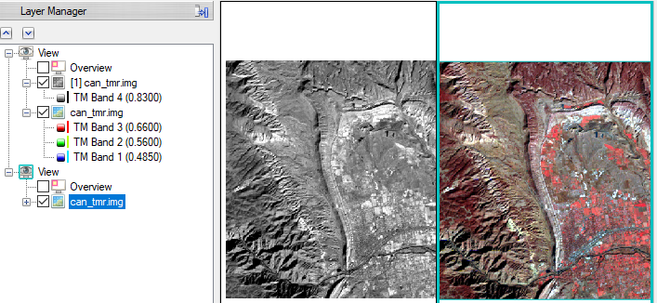

A view is similar to a “data frame” in ArcMap, it that can be used to display data side by side. To add a new View, in the menu select Views > Create New View. Add new data to the view using the Data Manager.

After removing the layers and closing the 2nd view pane.

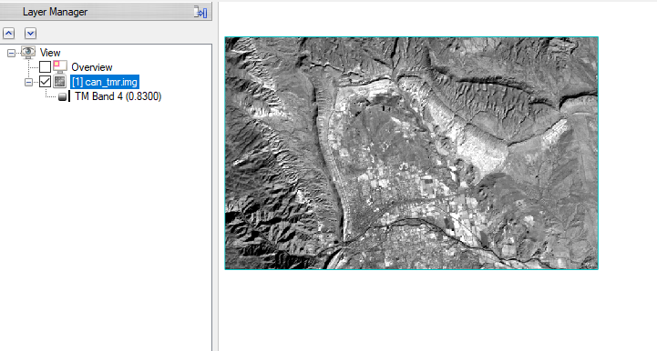

*\*Applying a Color Table*

To adjust the color table, right click on the data in the layer manager>change color table  
In the drop down menu there are resets, to make a custom color table, click on the rainbow color blob, there are three tabs that allow users to find the color they are looking for or define their own scheme.

Preset color table

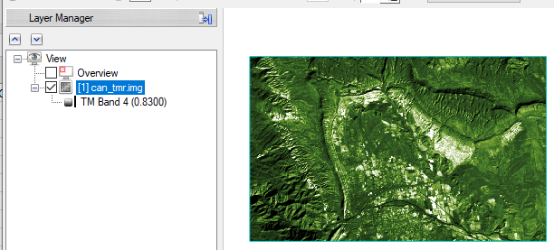

Custom color table

Here we create a custom color schema, this can be useful to allow the user to really display the information they are trying to capture in the image.

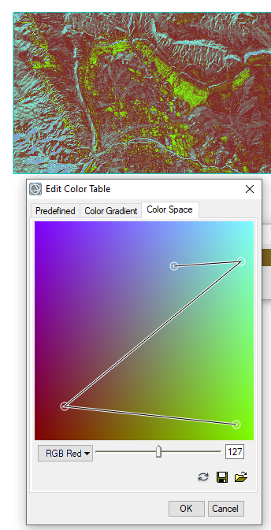

*\*Overlaying and Working with Vectors*

In this step of the lab we load a vector overlay over an image. This allows up to identify features of interest. The second portion of this step we learn how to edit the vectors and apply cleanup techniques that smooth out small variations in the vectors to make them easier to read.

Looking at file information and adding vector layers.

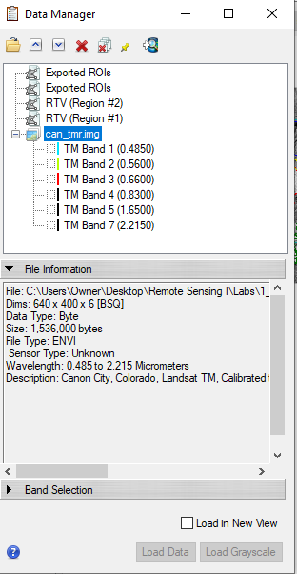 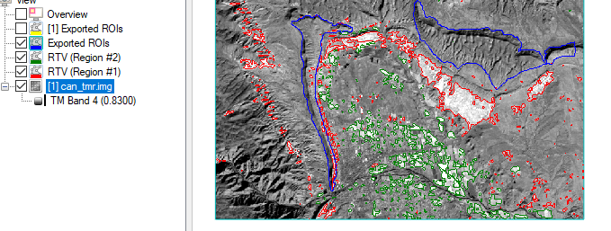

Vector editing (smoothing) Vertex editing

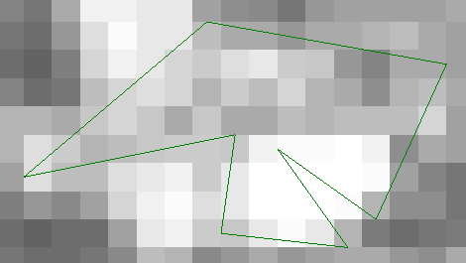 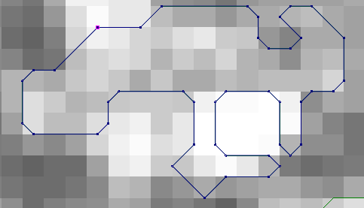

**Lab2** Vectors Tutorial

In this lab we start to create our own vector layers for an image to identify areas or features of interest. Creating and editing vectors is similar to how vectors are created in ArcMap. We have functionality to adjust the vector type, point, line or polygon and also have cleaup functionality that will smooth lines and reduce data noise.

*Opening and Displaying an Image

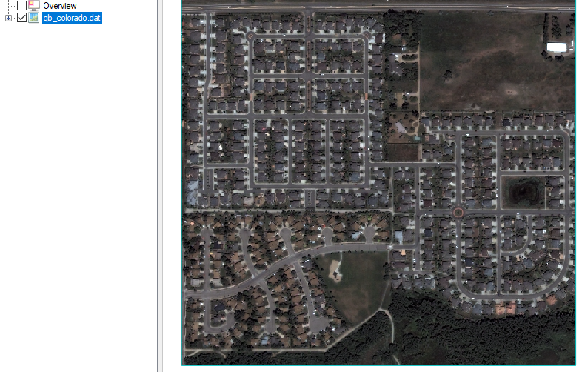

*\* Creating Vector Layers*

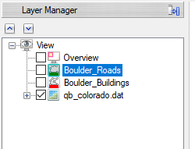

*\*Adding and Saving Vector Records*Creating Polylines (roads)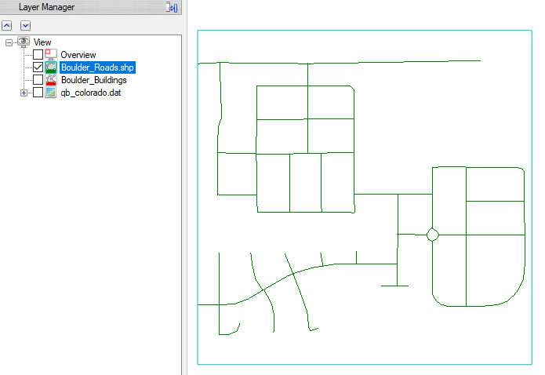

Switching between vector layers we must active the new layer we are transitioning to. To do this, we right click on the layer in the layer manager> Set as Active layer. Doing this allows us to edit the active layer… we can only manipulate the active layer.

Creating Polygons (buildings) After Editing vertex

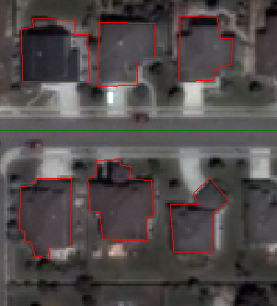 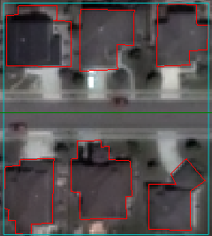

**Lab3** Annotations Tutorial

In the annotation tutorial we learn how to label areas within an image and add symbology to help display meaning in the image. For example, in this tutorial we draw add arrows to the image that could be used to show direction of travel. We also create labels that can be used to show significant features such as parks or similar land marks. In this lab we also learn that features we annotate can be manipulated and maintained the relationship as they were drawn to, for instance if a vector shows a direction, that relationship is preserved when the image is rotated.

*\*Creating an Annotation Layer*

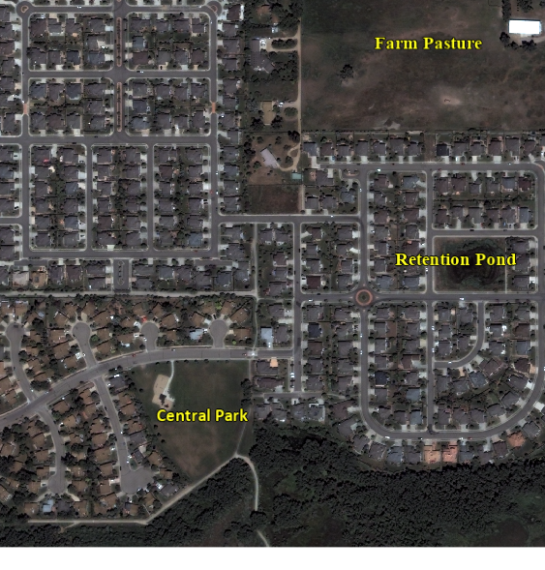 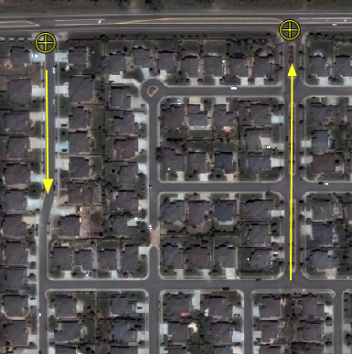

*\*Adding and Saving Annotation Items*

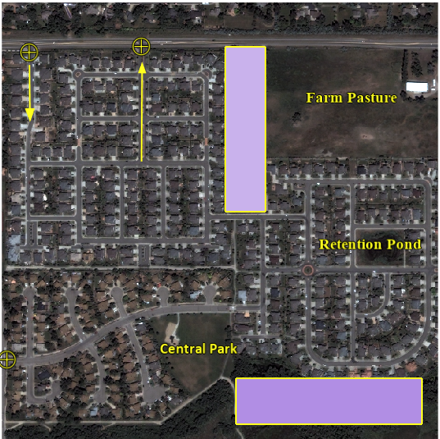 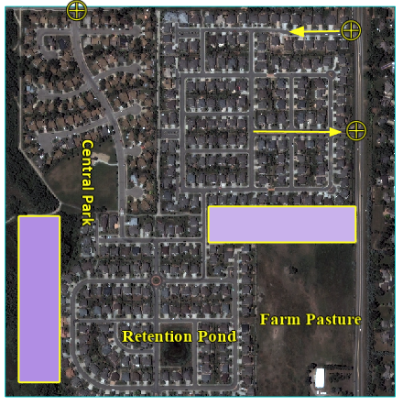

**Lab4** Image Change Tutorial & Thematic Change Tutorial

In the Image change tutorial, we learn methods that can be applied to observe how image of an area change temporally. In the example data we utilized before and after tsunami images to assess how the landscape was changed by the tsunami event. In this lab we start to use the preview window when inputting parameters. The preview window is very useful when performing these image analysis methods because it allows us to see if the parameters are accomplishing the goal without processing the full dataset.

Image Change Tutorial

*\*Selecting files for Image Change*

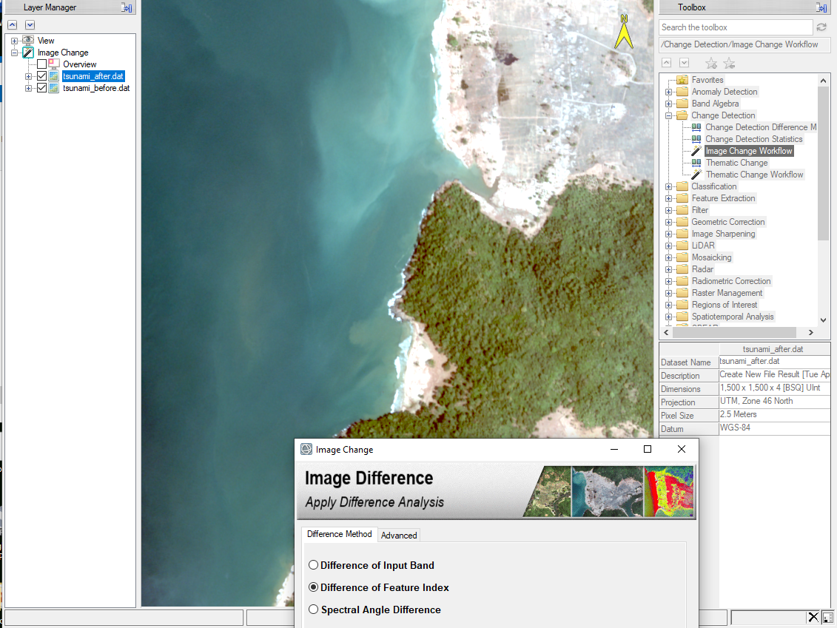

*\*Image Difference Settings*

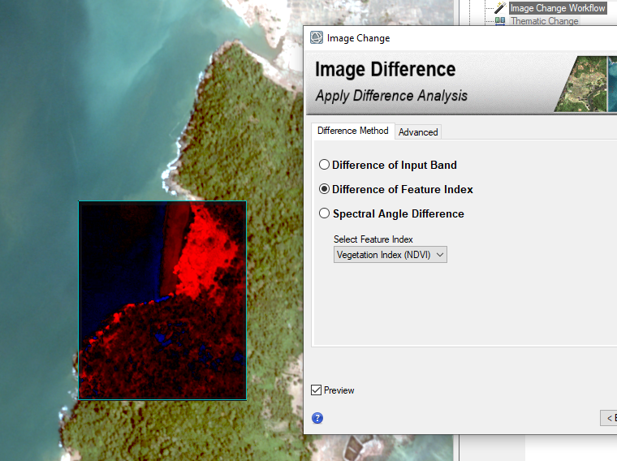

*\*Change Thresholding*

The change threshold allows the user to select different methods used to compare changes between the images. Some of the methods focus on displaying vegetation changes, other methods can be used to show land mass changes and some methods are used to show both vegetation changes and land mass changes. Below the Otsu method shows vegetation changes and land mass changes.

Otsu’s Kapur’s

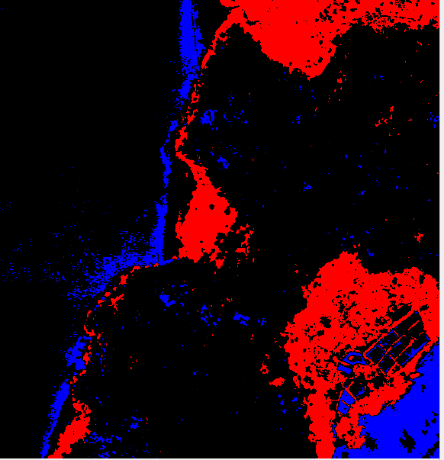 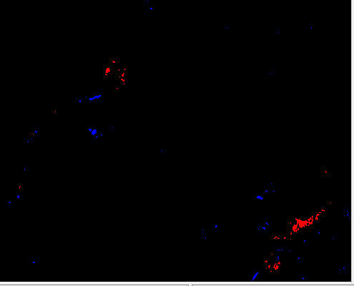

*\*Cleaning Up Image Change Results*

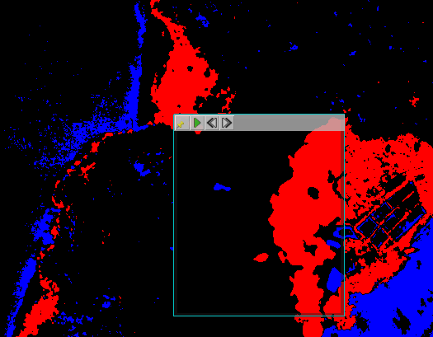

*\*Exporting Image Change Results*

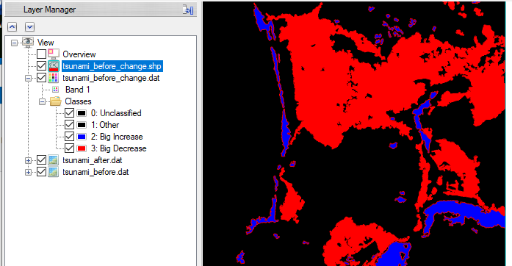

Thematic Change Tutorial

Thematic Change tutorial is similar to Image change. Thematic change detection takes two classification images of the same scene at different times and identifies differences between them. Thematic Change also allows the user to export table statistics that can be use to quantify the amount of change that occurs in the terms of area and % change. In this process, areas that remained the same in both images in classified as No Data. The output only keeps areas that have changed.

*\*Applying Thematic Change Analysis*

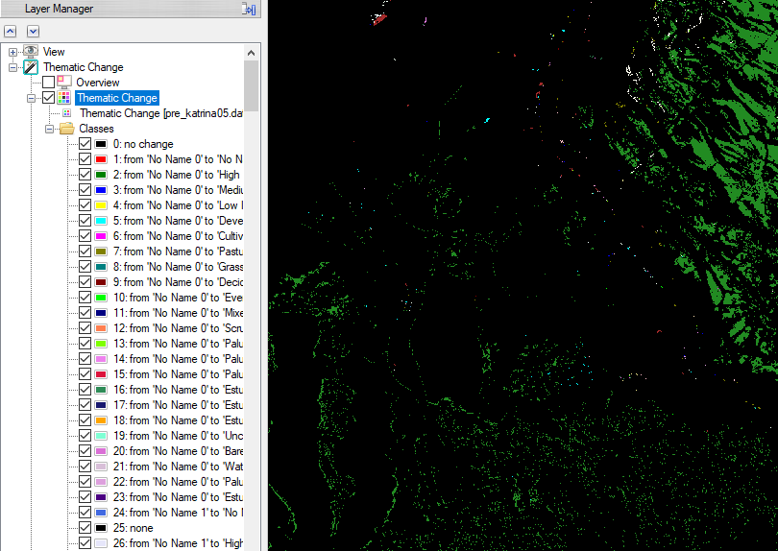

*\*Cleaning Up Thematic Change Results*

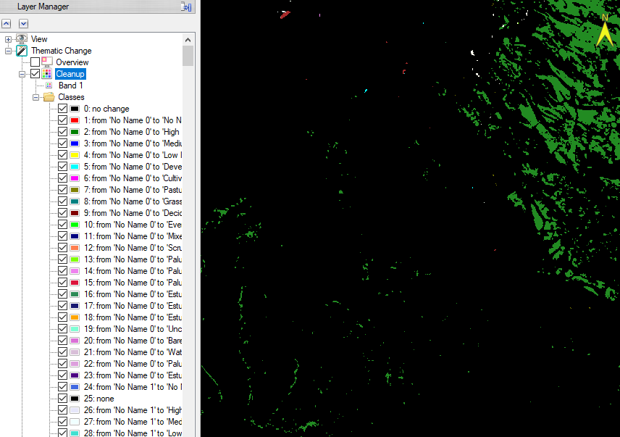

*\*Exporting Thematic Change Results*Viewer Output after export

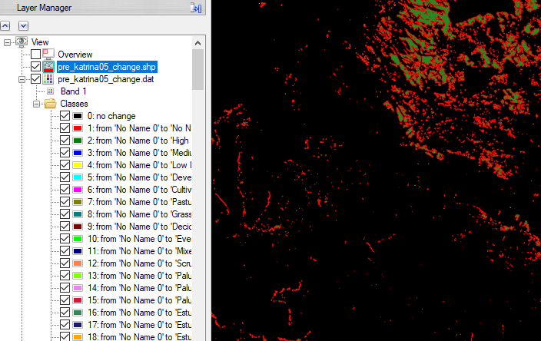

Exported Data Table from Thematic Change Results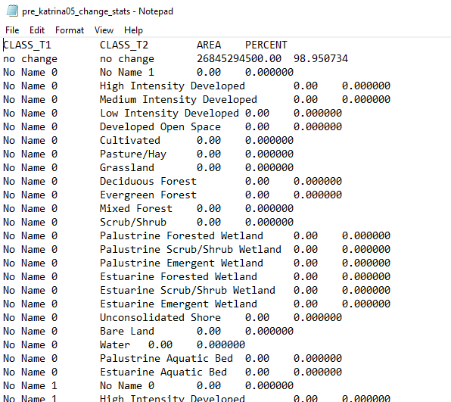

**Lab5** Classification Tutorial

In this lab we learn how to classify images using both supervised and unsupervised classification methods. In the unsupervised classification, the user does not define classes, rather the program clusters pixels in a dataset based on statistics only. Each class (ideally) represents similar objects or features captures in the image. This method is unsupervised because the user does not provide defined training classes.

In the supervised portion of this lab, the user manual defines areas in the image to classes. The computer statistically assesses these pixels and calculates a range of values that represent each respective class that was manually identified.

When classifying data, we are also able to save .SHP files! This is useful when applying the classification results to other spatial analysis applications.

*\*Performing Unsupervised Classification*

Before cleanup After cleanup

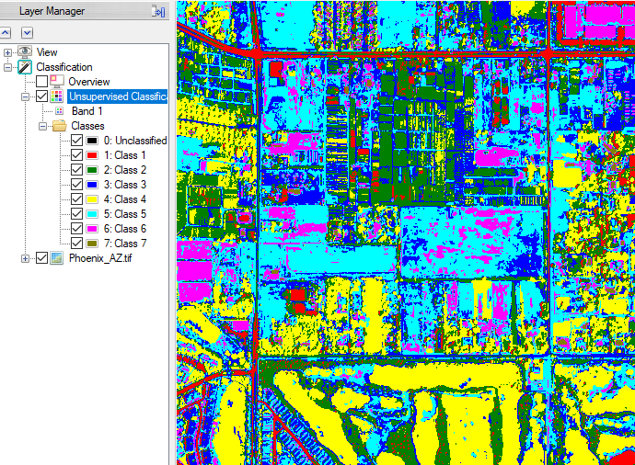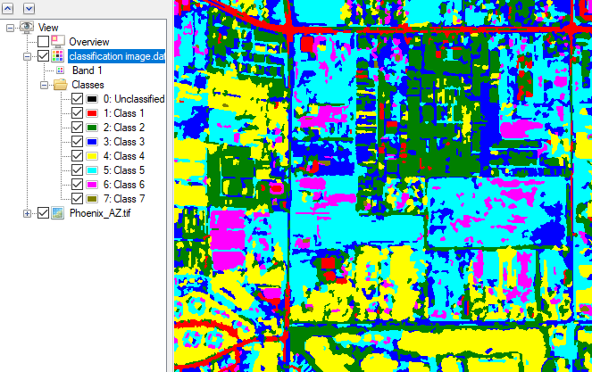

*\*Performing Supervised Classification*

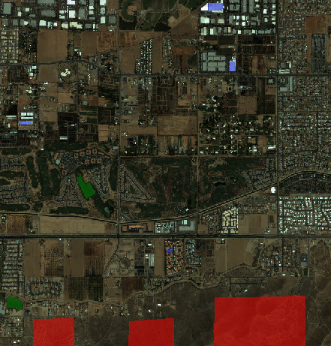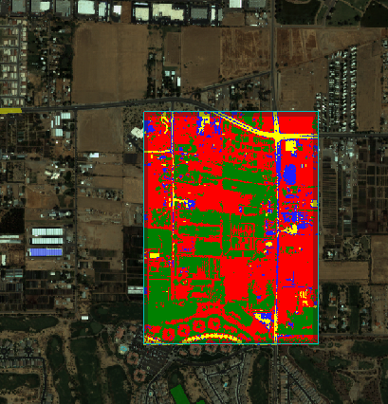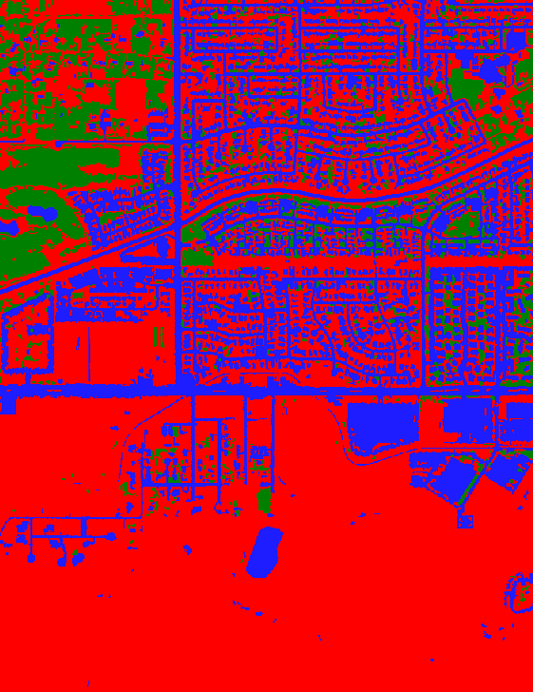

*\*Exporting Classification Results*

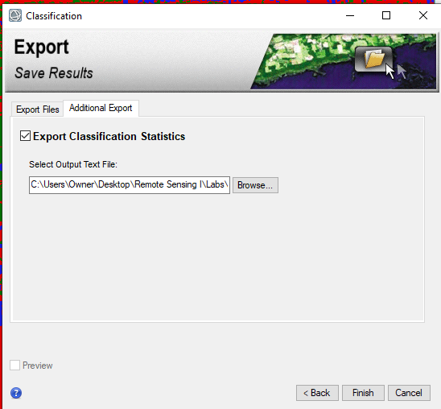

Exported files

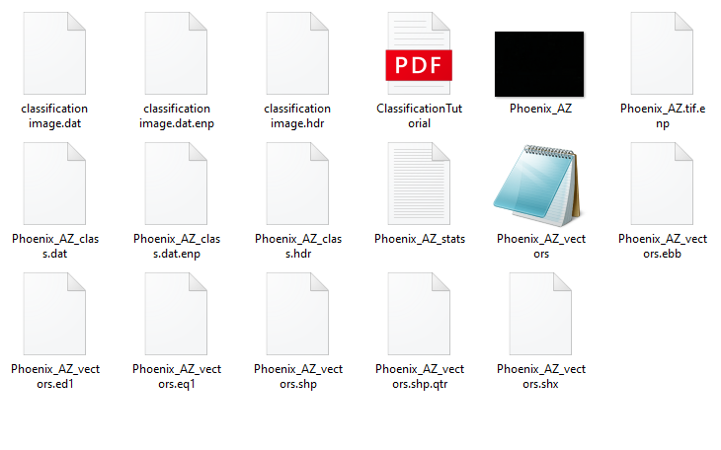

**Lab6** Burn Indices Tutorial

*Note: I ran into an issue completing the final step of this lab. The dialog box was acting glitchy and would remove the complimentary layer (see final section for more description and screen shots, plan to discuss this with peers on zoom workshop 5/6/2020- this note is a place holder if I am not able to return to the lab before submission deadline. It is my intent to complete this if time constraints allow).*

In the Burn indices lab, I learned to create water mask. This process locates surface water and dense water vapor such as thick clouds. This is useful when performing terrestrial analysis, in this scenario excluding water makes sense since the subject of this tutorial is wildfire management.

*\*Set Preferences and Display the Post-Fire Image*

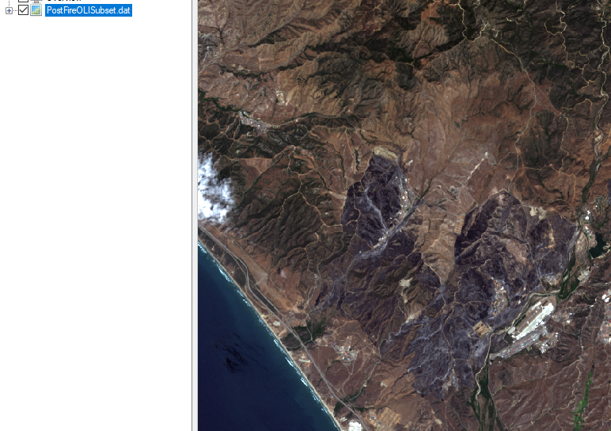

*\*Create a Water Mask*

The first step of this lab after setting our preferences is to create binary masks to exclude water pixels. This step locates water and dense water vapor.

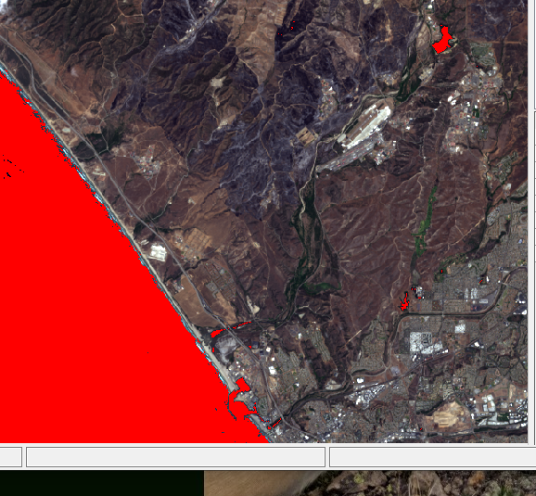

* *Calibrate OLI Bands to Reflectance*

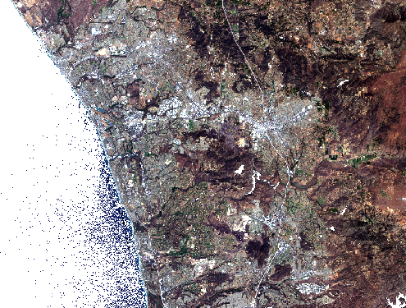

* Calibrate Thermal Bands to Brightness Temperatures

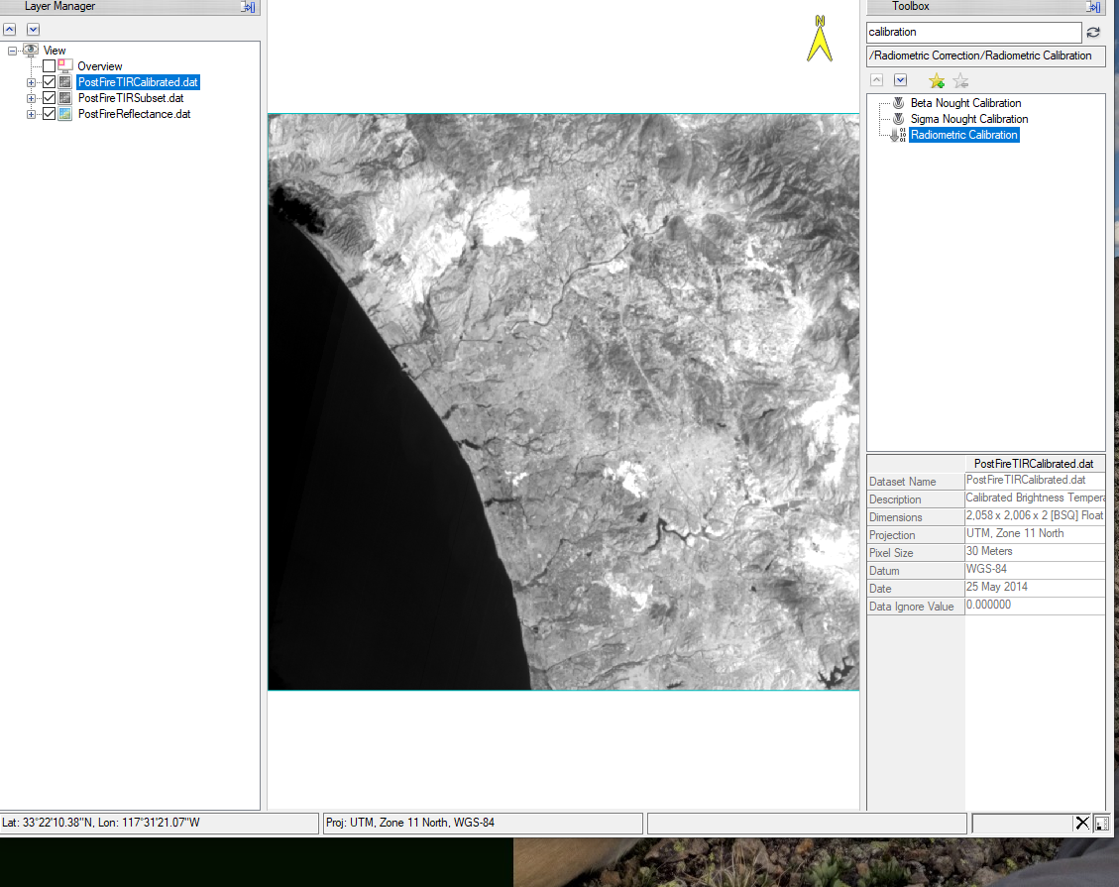

*\** *Create a Layer-Stacked Image*

In this step of the lab we create a layer-stacked image that includes the corrected multispectral and thermal band. This step of the lab we essentially combine the calibrated layers we created, each layer capturing a specific feature its calibrated to best represent.

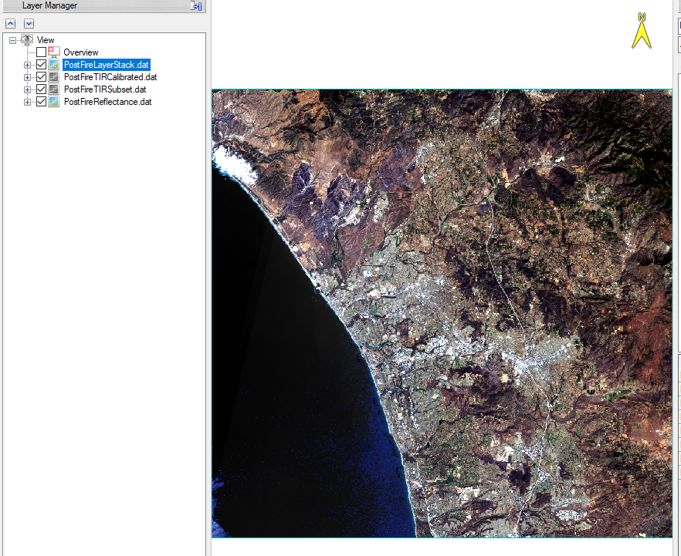 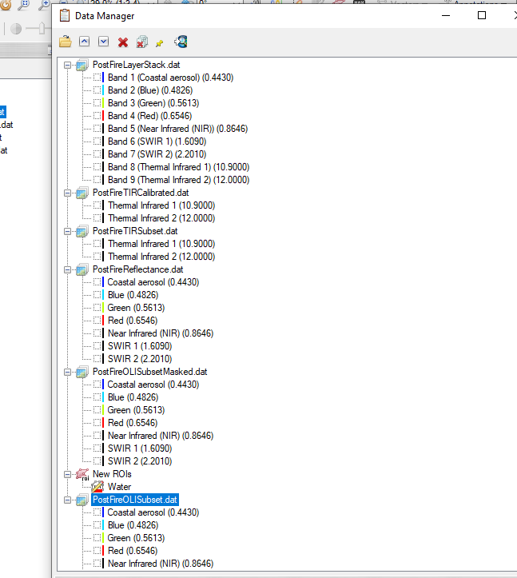

*\** *Create Burn Index Images*

This step shows us how all three layers look side by side and they are view linked to track centered on the same location in each window. This is useful because the user and you the pixel value icon and confirm each image is showing the data it is intended to show.

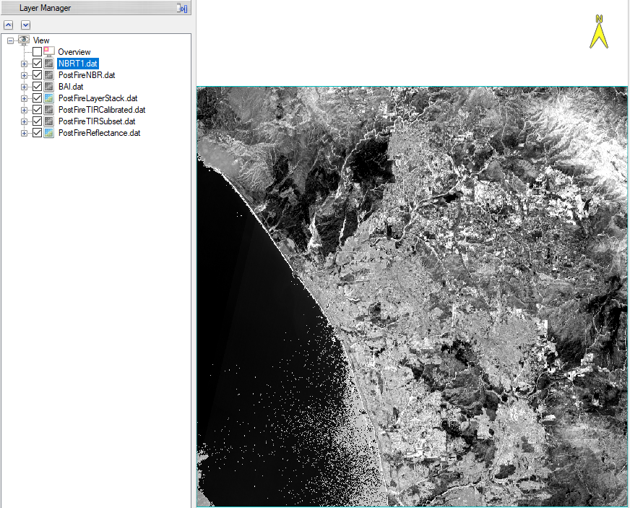 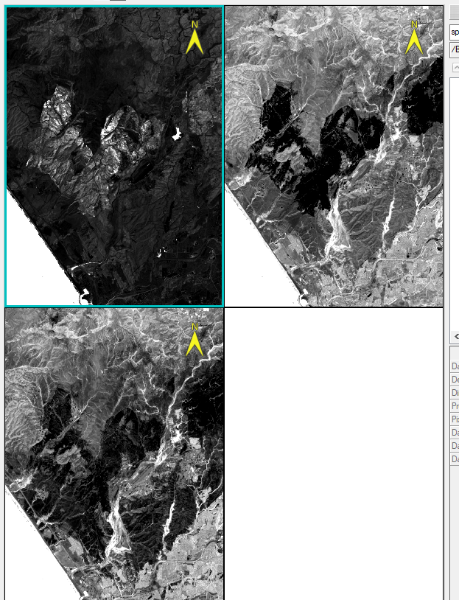

*\** *Differenced Normalized Burn Ratio*

The results of the final step is a density color slice file that is overlaid with the change-NBR. The final burn indices layers are useful for land managers to be able to identify areas and the intensity of fire they experience. This can be used to make future land management decisions. In the final image we can adjust the display to with the ability to focus in on areas of interest to better understand what happened in that area during the fire event.

